Common Issues & Fixes Required
1. Mobile UI & Layout Issues
- Layout breaks when typing in input fields
2. "How It Works" Section Placement
- Should appear below the calculator
- Design should be aligned or equivalent to the below
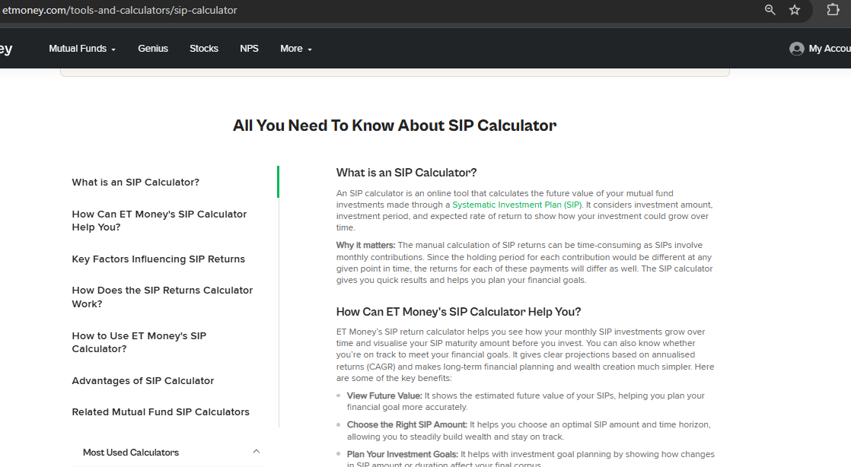
3. Article Links in All Calculators
- All calculators should display three article links
- "View All" button should navigate to the blog section
- Content is provided in a separate document and should be used as-is

Issues to Fix in Hand Salary Calculator
Other Allowance Amount
- Other Allowance amount is appearing incorrectly — needs correction
Old vs New Tax Regime Toggle
- Toggle is not working properly
- Toggle bar length should adapt dynamically based on the length of the "Enter Your Details" section
PF Toggle
Add a toggle to choose:
- Actual 12% of Basic
- Fixed ₹1,800 (₹21,600 cap)
Salary Calculation Order (Mandatory Flow)
- Mandatory contributions
- Tax calculation
- Salary components name should be changed to "Detailed Salary Breakdown"

Corrections to Salary Components
Tax Calculation
- Tax must be calculated on Gross Salary
- If Gross Salary ≤ ₹12,00,000, no tax should be shown
  - Currently, tax is still appearing — this must be fixed
- Example to verify: ₹13,80,000 (refer to ET Money calculation)
Formula:
Gross Salary = Basic + HRA + Special Allowance − Employer PF − Gratuity
Net (In-Hand) Salary Formula
Net Salary = Gross Salary − (Employee PF + Tax)
Display Format:
- This is how it should look (both monthly and yearly)
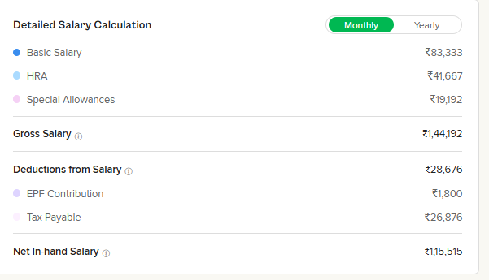

Please check a few calculations to ensure they match the results from etmoney.com.
https://www.etmoney.com/tools-and-calculators/salary-calculator
-------------------------------------------------------------------------
Tax Regime Calculators
Tax regime calculators should have the same computing logic as in-hand salary calculators.
-------------------------------------------------------------------------
Offer Analyzer Fixes
Default Display
- Show 2 offers by default
- Offer 1 and Offer 2: Display upfront, side-by-side layout on desktop
- Offer 3: Hidden by default, appears below on click
  - Button name should be "Add Offer 3"
Input Field Issues
- Basic & HRA input fields are not editable properly
- Backspace does not remove existing values (e.g., "4" in Basic, "5" in HRA)

EPF Calculator Fixes
PF Contribution Options
Allow users to choose:
- Actual 12% of Basic
- Maximum ₹1,800 (₹21,600 salary cap)
Growth & Age Logic
- Yearly growth is incorrectly shown from age 51
- Growth should start from the current age entered by the user
VPF (Voluntary Provident Fund)
- Include VPF option with a toggle bar
- Add minimum and maximum VPF contribution limits

Credit score --- In addition to the existing content, please add the following content exactly as provided below.

How is credit score calculated?
A credit score is calculated by credit bureaus using your past and current credit behaviour. It reflects how responsibly you manage borrowed money over time. While the exact calculation method is proprietary and differs slightly across bureaus, all credit scores are based on a common set of factors related to repayment history, credit usage, and borrowing patterns.
The most important factor in calculating a credit score is your payment history. This includes whether you pay your loan EMIs and credit card bills on time. Late payments, missed EMIs, defaults, or settled accounts can significantly reduce your score, while consistent on-time payments help build a strong credit profile.
Another major factor is credit utilisation, which measures how much of your available credit you are using. Using a large portion of your credit limit, especially above 30%, can negatively impact your score as it signals higher credit dependency. Keeping credit usage low and well within limits reflects better financial discipline.
The length of your credit history also plays an important role. Credit bureaus look at how long you have been using credit and the age of your oldest active account. A longer credit history generally improves your score, which is why closing old credit cards or long-standing loan accounts may sometimes reduce it.
Credit mix is also considered while calculating your score. A healthy balance of secured loans, such as home or car loans, and unsecured credit, like personal loans and credit cards, indicates that you can manage different types of credit responsibly. Relying heavily on only one type of credit may limit your score potential.
Finally, credit enquiries influence your score. Each time you apply for a loan or credit card, lenders make a hard enquiry on your credit report. Multiple enquiries in a short period can lower your score, as it suggests higher borrowing risk. However, checking your own credit score is a soft enquiry and does not affect your score.
Overall, credit scores are dynamic and change as your credit behaviour changes. Regular on-time payments, low credit utilisation, and responsible borrowing habits can improve your score over time, typically within three to six months. Credit scores may vary slightly across different bureaus, but the underlying factors used to calculate them remain largely the same
——————————————---------------------------------------------\
Advantages of Maintaining a Good Credit Score
• Higher loan approval chances
Lenders are more likely to approve your loan applications when you have a good credit score.
• Lower interest rates
A strong credit score can help you get loans and credit cards at lower interest rates, reducing overall borrowing costs.
• Better credit card offers
You become eligible for premium credit cards with higher limits, rewards, and exclusive benefits.
• Faster loan processing
Good credit scores often lead to quicker approvals with minimal documentation.
• Higher credit limits
Banks are more willing to offer higher loan amounts and increased credit card limits.
• Pre-approved offers
You may receive pre-approved loans and credit card offers based on your credit profile.
• Improved financial credibility
A good credit score reflects responsible financial behaviour and builds trust with lenders.
• Greater financial flexibility
Easier access to credit helps you manage emergencies and plan long-term financial goals confidently.
—————————————————————-
Factors That Affect Your Credit Score
• Payment history
Timely payment of loan EMIs and credit card bills has the biggest impact on your credit score. Late payments, missed EMIs, defaults, or settlements can significantly reduce your score.
• Credit utilisation
This refers to how much of your available credit limit you use. High credit usage, especially above 30% of your limit, can negatively affect your score.
• Length of credit history
Credit bureaus consider how long you have been using credit. Older and well-maintained accounts generally improve your credit score, while closing old accounts may lower it.
• Credit mix
Having a healthy balance of secured loans (like home or car loans) and unsecured credit (like personal loans and credit cards) shows responsible credit management.
• Credit enquiries
Every time you apply for a loan or credit card, lenders make a hard enquiry on your credit report. Multiple enquiries in a short period can reduce your score.
• Number of active accounts
Managing too many loans or credit cards at the same time can increase risk perception and impact your score negatively.
• Loan defaults and settlements
Accounts marked as defaulted or settled have a strong negative impact and can stay on your credit report for several years.
• Errors in credit report
Incorrect personal details, wrong loan statuses, or unrecognized accounts can also affect your credit score if not corrected.
—————————————————-
Tips to Improve Your Credit Score
• Pay all EMIs and credit card bills on time
Timely payments have the biggest positive impact on your credit score. Even a single missed payment can reduce your score.
• Keep credit utilisation low
Try to use less than 30% of your total credit limit. High credit usage signals financial stress and negatively affects your score.
• Avoid multiple loan or credit card applications
Applying for several loans or cards in a short period leads to multiple credit enquiries, which can lower your score.
• Maintain old credit accounts
Older accounts help build a longer credit history. Avoid closing old credit cards unless absolutely necessary.
• Use a healthy mix of credit
Balance secured loans (home or car loans) with unsecured credit (credit cards or personal loans) to show responsible borrowing behaviour.
• Clear overdue amounts quickly
If you have missed payments or dues, clear them as soon as possible to limit long-term damage.
• Check your credit report regularly
Review your credit report for errors such as incorrect balances or unknown accounts and get them corrected promptly.
• Avoid loan settlements if possible
Settling a loan for less than the due amount can hurt your credit score more than closing it fully.
• Limit credit card usage
Spread expenses across cards if needed and avoid maxing out any single card.
• Be patient and consistent
Credit score improvement takes time. With disciplined credit behaviour, positive changes usually reflect within 3–6 months.
—————————————————-
Who maintains credit score
In India, credit scores are maintained by credit bureaus, which are authorized organizations that collect and manage individuals’ credit information from banks and financial institutions.
Credit Bureaus in India
The Reserve Bank of India (RBI) has licensed four credit bureaus to maintain credit records and generate credit scores:
• TransUnion CIBIL
The most widely used credit bureau in India. Most banks and lenders refer to CIBIL scores for loan and credit card approvals.
• Experian India
An international credit bureau that provides credit reports and scores used by many banks and NBFCs.
• Equifax India
Collects and maintains credit data and is used by several financial institutions.
• CRIF High Mark
Commonly used for retail loans, microfinance, and NBFC lending.
How They Maintain Your Credit Score
These credit bureaus receive data regularly from banks, NBFCs, and credit card companies about your loans, credit cards, repayments, and defaults. Based on this information, they calculate and update your credit score periodically. While the score may vary slightly between bureaus, the underlying credit behaviour used to calculate it remains largely the same.
Important: You do not “maintain” your credit score yourself—your financial behaviour does. Credit bureaus only record and calculate it based on the data reported by lenders.

Insurance - In addition to the existing content, please add the following content exactly as provided below.
Why Insurance Planning Matters
Insurance planning helps protect you and your family from unexpected financial risks such as medical emergencies, accidents, loss of income, or damage to property. Without adequate insurance, even a single unforeseen event can disrupt long-term financial goals and savings. Proper insurance planning ensures financial stability, peace of mind, and the ability to handle emergencies without relying on loans or selling assets.
Which Insurance Do You Need?
Choosing the right insurance depends on your life stage, income, and responsibilities. Not everyone needs every type of insurance, but having the right mix is important.
For Salaried Individuals
• Life Insurance (term plan for income protection)
• Health Insurance (individual or employer + personal cover)
• Motor Insurance (mandatory if you own a vehicle)
For Families
• Life Insurance with higher coverage
• Family floater health insurance
• Home insurance if you own a house
For Self-Employed or Freelancers
• Health insurance with a top-up plan
• Term life insurance
• Optional income protection plans
Common Insurance Mistakes to Avoid
Many people buy insurance without proper understanding. Avoid these common mistakes:
• Buying insurance only for tax savings
• Choosing very low coverage to reduce premiums
• Relying only on employer-provided health insurance
• Not reviewing or updating policies after major life events
• Ignoring policy exclusions and claim conditions
How Much Insurance Coverage Is Enough?
Having insurance is important, but having adequate coverage matters even more.
• Life Insurance:
Coverage should be around 10–20 times your annual income to support your family’s future expenses.
• Health Insurance:
At least ₹5–10 lakh for individuals and ₹10–20 lakh for families, depending on city and medical costs.
• Home Insurance:
Coverage should match the full reconstruction value of your property, not the market price.
• Motor Insurance:
A comprehensive policy along with mandatory third-party coverage is recommended for better protection.

